[E116] Mash temperature sensor

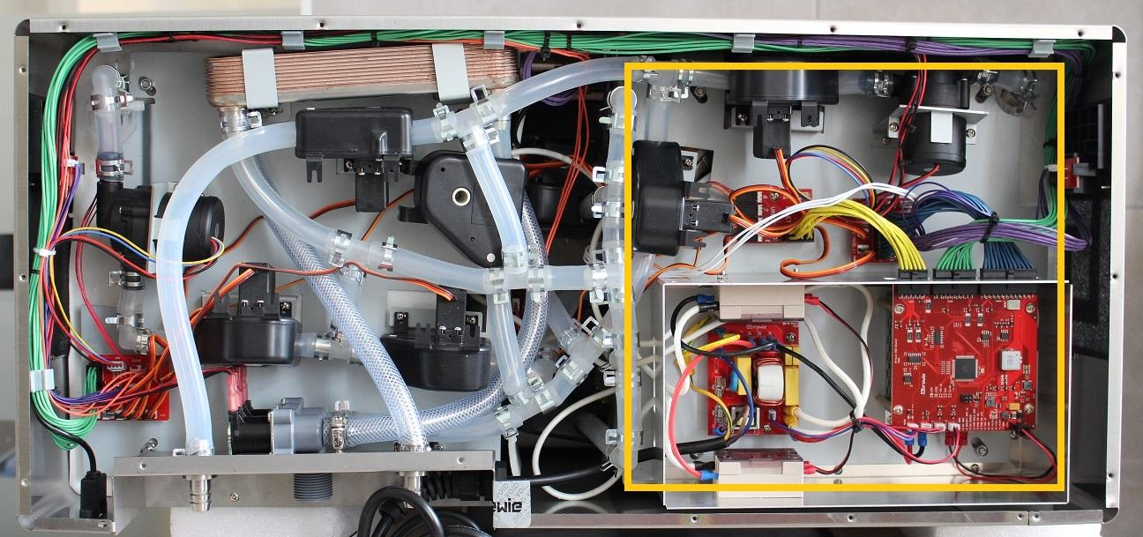

The mash temperature sensor is located under the mash side service plate attached to the side of the mash tank.

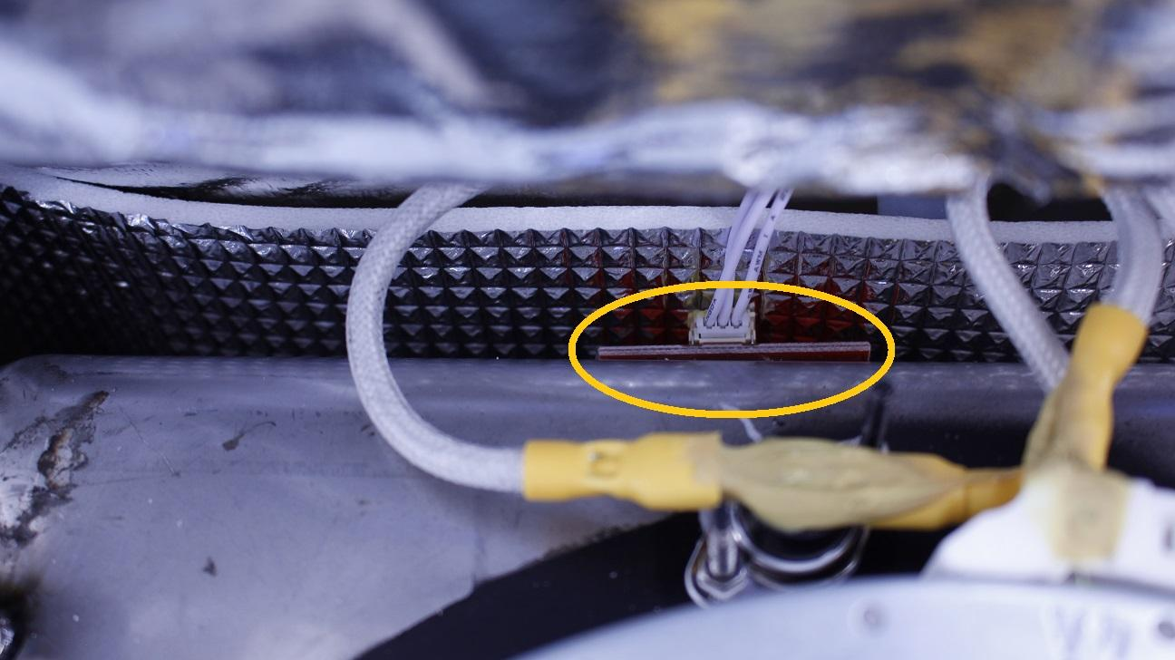

To reach the temperature sensor it is necessary to partially remove the plate:

1. Disconnect the silicone tube from the outlet of the mash tank by pulling off the clamp then the tube from the L fitting.
2. Disconnect the purple cable from button PCB.
3. Remove the cable bundle from the two marked holders.
4. Unscrew the marked 4 locknuts holding the mash plate.

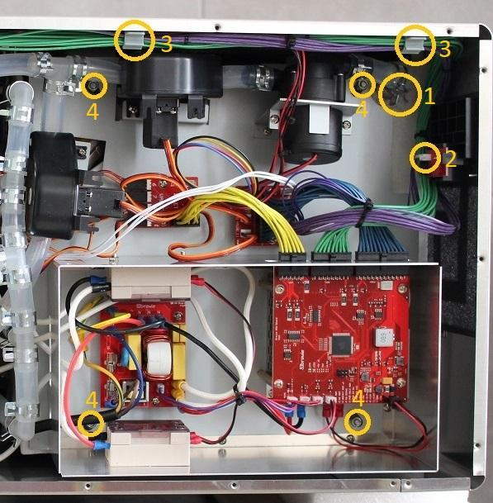

Open up the whole plate.

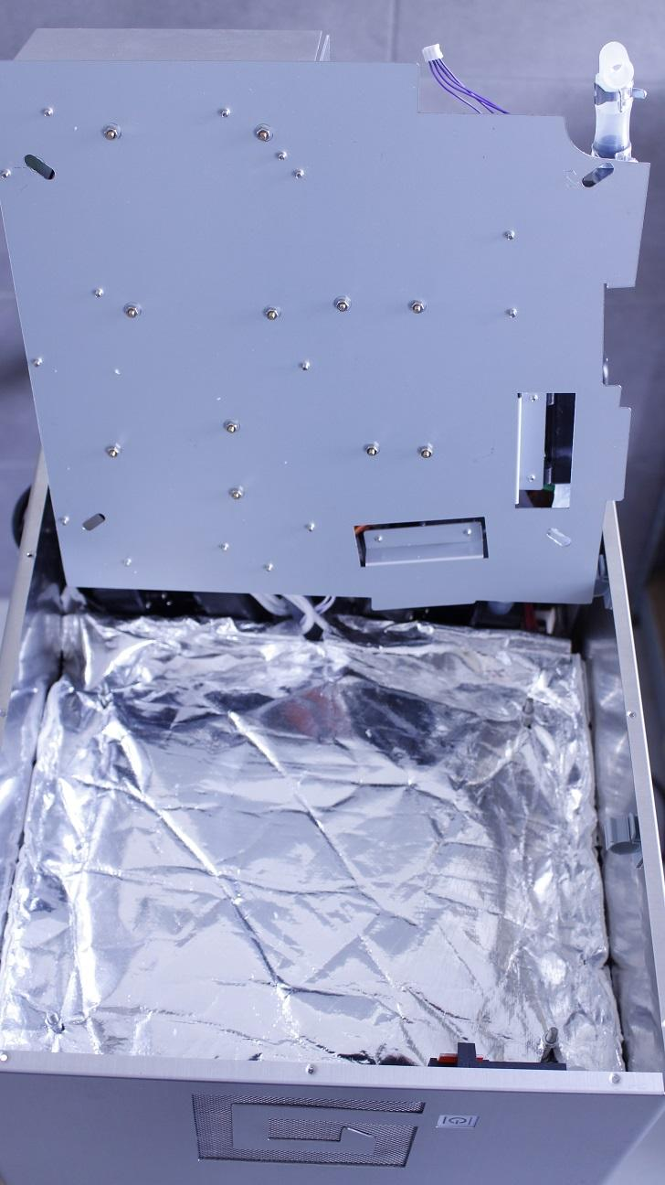

Carefully pull off the heat insulation from the threads and the outlet pipe.

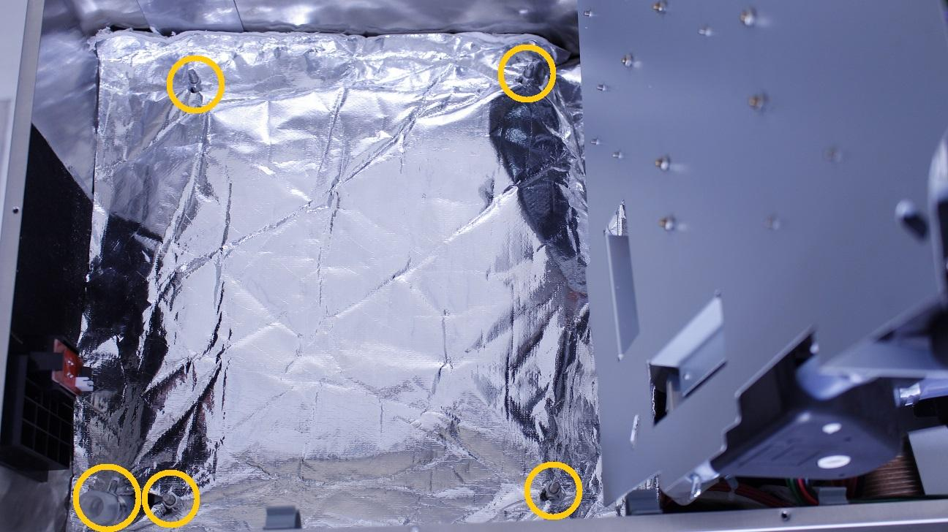

Simply turn the fastening clamps aside from the heater element and remove the isolation rubber.

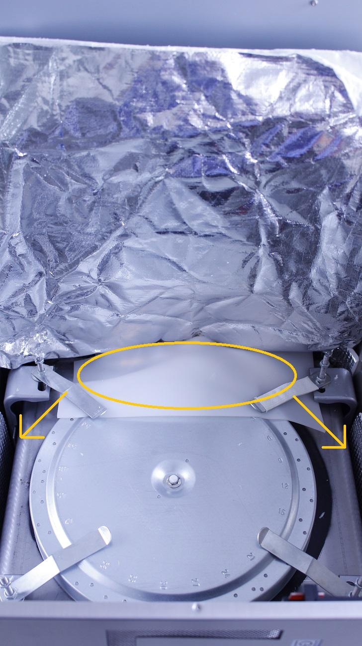

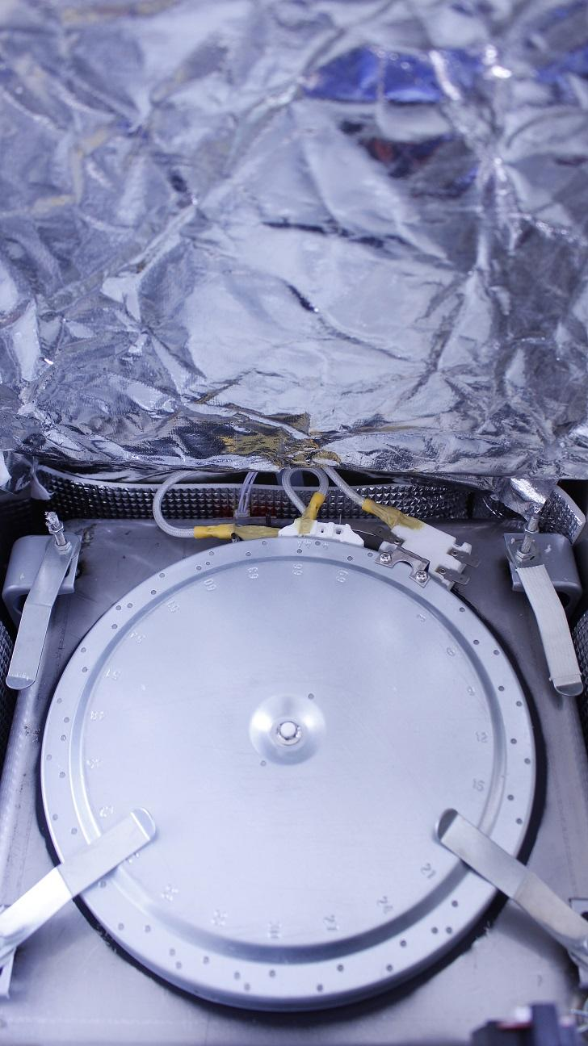

The temperature sensor can’t be replaced. A new one has to be glued to the side of the tank and the existing cable has to be connected to that. To avoid confusion, break the connector of the old sensor with a plier.



Reassemble consists of the same steps in reverse.